HUMBER INSTITUTE OF TECHNOLOGY

AND ADVANCED LEARNING

(HUMBER COLLEGE)

**Capstone Project Final Report**

Submitted by: Group 18

|  |  |  |
| --- | --- | --- |
| **Last Name** | **First Name** | **Student Number** |
| Anjali | Patel | N01510772 |
| Astha | Awale | N01510591 |
| Sairohit | Chowdhary | N01510624 |
| Meutia | Putri | N01510783 |
| Vaibhav | Ahuja | N01473001 |

Submitted to:

Professor Pawandeep Singh

Submission Date:

**1. Executive summary**

This report outlines the Centre for Addiction and Mental Health's (CAMH) efforts to revolutionize patient data management. CAMH faced a critical business challenge in its current data management practices as they heavily relied on paper form and excel to store their patient’s data, which was time-consuming, error-prone, and lacked the ability to provide real-time insights. To overcome these hurdles, we have implemented a transformative solution that encompasses the creation of a centralized electronic database, facilitating the seamless migration of data from paper forms to digital records. An ETL process was designed to automate data integration, ensuring accuracy and consistency. The implementation of interactive Power BI dashboards were able to answer critical analytical questions which empowered stakeholders with visualized insights into patient demographics, clinical characteristics, visit reasons, and potential correlations between past admissions and addiction information. The project aimed to streamline data management, enhance data accuracy, and provide real-time insights to improve patient care and overall operational efficiency. The report also highlighted the importance of data quality, security, and privacy, as well as the need for rigorous testing to ensure the strength of the solution. The project's primary objectives were focused on optimizing the patient registration process and improving overall data management within the Mental Health program. This report provided a glimpse into a future where optimization reigns and continuous improvement is the norm, highlighting the importance of visualizing the horizon of perpetual sophistication and the need for a more effective, efficient, and compassionate healthcare landscape. Overall, this report showcased CAMH's commitment to revolutionizing patient data management and improving the overall quality of care for their patients.

**2. Introduction**

This report demonstrates CAMH's commitment to revolutionizing patient data management. Section 1 will focus on discovering a brief but comprehensive overview of our efforts. This section summarizes the main content of this report and provides an overview of the transition that CAMH is about to complete. Sections 3 & 4 will focus on the overview and challenges faced by CAMH and we will also discuss the analytics questions, which will guide us with insights that will shape our data-driven decisions and patient care strategies. In section 5 we will familiarize ourselves with the scope statement and which in turn will clarify the areas where our project will achieve its impact. Section 6 will focus on the essential data sources and entities that form the foundation of our digital revolution. In the next section which is section 7, we will focus primarily on output and data manipulation, shedding some light on the expected outcomes which will empower our healthcare providers. Section 8 will be focusing on the design and integration of new solutions so that we can integrate our IT architecture. This section paints a picture of our technology evolution. We will be implementing the solution and checking the results so that we know it is backed by rigorous testing to ensure its strength. The last section will focus on visualizing the horizon of perpetual sophistication. This section will provide a glimpse into a future where optimization reigns, continuously improving operational efficiency and patient care. As you read through this report, imagine the future we are shaping – an area where patient care technology comes together in a harmonious symphony. Each section, meticulously tailored, guides you toward the pinnacle of a more effective, efficient, and compassionate healthcare landscape.

**3. Business Problem Overview**

In the dynamic landscape of modern healthcare, our client, The Centre for Addiction and Mental Health (CAMH), a prominent mental healthcare organization, faces a critical business challenge in its current data management practices. Currently, CAMH relies on traditional paper forms to record and gather essential patient information, including demographic details, reasons for visits, addiction history, and previous hospitalizations. This data is then manually transcribed and stored in Excel spreadsheets, resulting in inefficiencies, data fragmentation, and potential inaccuracies. The existing data management process is time-consuming, error-prone, and lacks the ability to provide real-time insights. This disjointed approach impedes the organization's ability to make informed decisions, hindering the quality of patient care and overall operational efficiency. To overcome these hurdles, we have proposed a transformative solution.

This comprehensive initiative encompasses the creation of a centralized electronic database, facilitating the seamless migration of data from paper forms to digital records. An ETL (Extract, Transform, Load) process will also automate data integration, ensuring accuracy and consistency. The implementation of interactive Power BI dashboards will empower stakeholders with visualized insights into patient demographics, clinical characteristics, visit reasons, and potential correlations between past admissions and addiction information. This undertaking project aims to streamline data management, enhance data accuracy, and provide a powerful platform for data-driven decision-making, ultimately improving patient care and operational efficiency at CAMH as the business problem that our client is facing encapsulates the pressing need for efficient data management and the journey undertaken to unlock the true potential of healthcare data for informed decision-making and improved patient outcomes.

**4. Analytics Questions**

Question 1: What are the key demographic and clinical characteristics of the patients?

* Type of Analytics: Descriptive Analytics.
* Required Analytics: Data summarization, data profiling, and exploratory data analysis.
* Predictions: No specific predictions are required for this question.
* Insights for Decisions: Understanding the demographic and clinical characteristics will help in identifying patterns, trends, and potential risk factors associated with mental health issues. This information can assist in resource allocation, treatment planning, and identifying target populations for intervention programs.

Question 2: What are the most common reasons for patient visits?

* Type of Analytics: Descriptive Analytics.
* Required Analytics: Data aggregation, frequency analysis, and categorization.
* Predictions: No specific predictions are required for this question.
* Insights for Decisions: Identifying the most common reasons for patient visits will provide insights into the prevalent mental health issues and the specific areas where resources and interventions may be needed. This information can aid in prioritizing treatment options and designing targeted awareness campaigns.

Question 3: Are there any correlations between past admissions and addiction information?

* Type of Analytics: Diagnostic Analytics.
* Required Analytics: Correlation analysis and association rules mining.
* Predictions: Predictive Analytics - Predict the likelihood of addiction based on past admissions and vice versa.
* Insights for Decisions: Understanding the correlation between past admissions and addiction information can help in identifying potential risk factors and designing personalized treatment plans. Predicting the likelihood of addiction based on past admissions and vice versa can assist in early intervention and preventive measures.

Question 4: How does patient age correlate with different mental health conditions?

* Type of Analytics: Diagnostic Analytics.
* Required Analytics: Correlation analysis and data visualization.
* Predictions: No specific predictions are required for this question.
* Insights for Decisions: Examining the correlation between patient age and different mental health conditions can provide insights into age-related vulnerabilities, prevalence, and treatment effectiveness. This information can inform the development of age-specific interventions, targeted screening programs, and resource allocation.

**5. Scope statement**

This scope statement outlines the objectives and boundaries of the Capstone Project, which seeks to modernize the patient registration process and enable data analysis for the Mental Health department. The project entails transitioning from paper-based forms to a centralized database, executing data migration and transformation procedures, and creating a comprehensive dashboard for data visualization.

a) Project Objectives: The primary objectives of the Capstone Project are focused on optimizing the patient registration process and improving overall data management within the Mental Health program. This involves transitioning from paper forms to a centralized database system to enhance efficiency in patient data storage, retrieval, and analysis. The project also includes automating the migration of historical patient data to the new system through a well-defined mapping process. To facilitate seamless integration of data from diverse sources, an Extract, Transform, Load (ETL) solution will be implemented. Additionally, the project aims to develop an interactive dashboard that offers real-time monitoring, analysis, and visualization of key performance indicators (KPIs) relevant to the program. Through comprehensive data analysis, the project will uncover correlations between factors like income, addictions, and readmission probabilities, providing valuable insights for the program's improvement.

b) Project Deliverables: The Capstone Project will deliver essential components, including a secure centralized database for efficient patient data management, an illustrative Entity-Relationship Diagram (ERD) showcasing data structures, automated data migration from paper forms with adherence to mapping rules, seamless ETL integration for diverse data sources, and an interactive dashboard enabling real-time monitoring and analysis of key Mental Health program indicators.

c) Project Limitations or Exclusions: It does not involve clinical diagnosis or treatment decisions; integration with other healthcare systems is excluded; ongoing maintenance, end-user training, and hardware/software procurement are not covered. While adhering to data regulations, complex legal compliance falls outside the scope. The project focuses on modernizing patient registration, data management, ETL processes, and dashboard design within the Mental Health department.

**6. Data sources/key data entities and flows**

The process flow data diagram provides a comprehensive visual representation of the intricate workflows and interconnected procedures that define the operations at the Centre for Addiction and Mental Health (CAMH). Its primary objective is to optimize operations, enhance communication, and ensure high-quality care by mapping out the journeys undertaken by patients, caregivers, and staff members. Upon exploring the various pathways within this diagram, it becomes evident that CAMH places a strong emphasis on empathy, confidentiality, and evidence-based practices. Each chart illustrates different scenarios, outlining the patients' journeys through CAMH and the data collection process at various stages.

The Illustration 1: “An Overview of Patient Interactions at the Hospital” in the appendix depicts the preliminary engagement of patients with the hospital. It delineates three distinct scenarios:

1. Non-Emergency Walk-In Patient: In this scenario, a patient arrives at the hospital without a prior appointment. The initial interaction involves capturing the patient's reason for seeking medical assessment.

2. Appointed/Follow-Up Patient: This scenario pertains to patients who have scheduled appointments or follow-up visits. Upon their arrival, the reason for assessment is recorded as part of the preliminary interaction.

3. Emergency Walk-In Patient: Patients with urgent medical needs fall into this category. Similar to the other scenarios, their reason for assessment is promptly recorded upon arrival.

Irrespective of the scenario, the common process involves collecting pertinent information. During the registration stage, crucial demographic details are captured, including biological sex, date of birth, marital status, and primary language. Subsequently, utilizing these demographic particulars, a unique patient_ID is generated within the system. This patient_ID serves as an exclusive reference point for accessing any patient-related information in the future. This approach ensures a streamlined and systematic management of patient interactions, enabling efficient information retrieval and overall healthcare administration.

In Illustration 2: "Comprehensive Patient Data Collection for Enhanced Diagnosis and Treatment Planning: Non-Emergency Walk-In Scenario" it is evident that when dealing with a non-emergency walk-in patient, the nurse and doctor engage in collecting additional information. This meticulous data collection serves a dual purpose: ensuring precise diagnosis and facilitating the proper prescription of medical tests and suitable medications. The comprehensive range of information encompasses the patient's highest level of education, current employment status, indications of coverage under employment insurance, indicators of pension benefits, records of received social assistance, presence of disability insurance coverage, identification of alternative income sources, the cumulative duration of previous hospitalizations, the patient's interaction with community mental health services, the count of recent psychiatric admissions, the overall historical count of psychiatric admissions throughout the patient's life, and the duration elapsed since the patient's most recent discharge from the hospital.

This exhaustive data collection approach plays a pivotal role in enhancing the accuracy and effectiveness of diagnostic procedures, treatment planning, and overall healthcare management for non-emergency walk-in patients.

When a patient arrives at the hospital for a scheduled appointment or follow-up as seen in Illustration 3: "Integrated Patient Assessment and Record Management in Hospital Appointments and Follow-ups", a systematic process unfolds. The nurse utilizes the patient's distinctive patient ID to access their records, ensuring that the file is primed for the doctor's evaluation. Subsequently, the doctor undertakes a comprehensive assessment of the patient, effecting essential updates to their records. These updates encompass a range of critical indicators, including the number of recent psychiatric admissions, the cumulative count of psychiatric admissions over the patient's lifetime, any changes in the usage of psychotropic medications, as well as any involvement with psychiatric, psychological, psychometric, and psychosocial rehabilitation services.

Moreover, if the patient necessitates consultation for family support, family therapy, or couple therapy, these aspects are meticulously recorded. Additionally, factors pertaining to the patient's social and family functioning are diligently documented. Finally, the patient's discharge date is meticulously captured when they are ready to be discharged from the hospital.

This intricate process not only ensures accurate record-keeping but also facilitates comprehensive patient care, effective treatment planning, and seamless collaboration between medical professionals to address the patient's holistic well-being.

As seen in Illustration 4: "Streamlined Data Collection for Diagnosis and Treatment" cases of emergency patient care, swift action is paramount for hospital staff. Concurrently, it is imperative to expediently gather and preserve all pertinent data to ensure future patient diagnoses. The overseeing nurse takes charge of this process, meticulously collecting the patient's demographic details along with supplementary information, which includes:

1. Addiction Counselor Involvement: This flag signifies the engagement of an addiction counselor in the patient's mental health treatment. These specialists provide tailored counseling and support to address substance abuse or addiction-related issues effectively.

2. Alcohol, Drug Treatment, and Smoking Cessation Participation: This indicator denotes the patient's involvement in programs or interventions designed to address alcohol and drug-related concerns as well as smoking cessation. These initiatives offer comprehensive support, counseling, and strategies to aid individuals in overcoming addiction, managing cravings, and successfully quitting smoking.

3. Psychologist or Psychometrist Engagement: This marker indicates the presence of a psychologist or psychometrist in the patient's mental health treatment. Their involvement encompasses psychological assessment and therapeutic interventions.

These additional inquiries significantly aid the doctor in formulating an accurate diagnosis and tailoring suitable treatment approaches. The expedited data collection ensures that critical patient information is readily available for timely and effective medical interventions.

**7. Brief Overview of Data Manipulation Process & Data Output**

Data manipulation is the process of transforming, reorganizing, and refining raw data to make it more suitable for analysis, reporting, or other specific purposes. This process involves a series of steps to ensure that the data is structured, formatted, and organized in a way that facilitates effective analysis and decision-making. The data manipulation process includes:

*1. Data Review and Understanding:*

The initial steps involve a thorough examination of the layout of the Excel sheet. This includes closely observing the column headers and understanding their respective meanings. As part of this process, it's important to identify any columns that could potentially function as unique identifiers. These could be in the form of IDs or other distinct markers that have the capability to serve as primary keys within a database structure. This careful analysis of the Excel sheet's contents sets the groundwork for effectively organizing and utilizing the data in a database system.

*2. Data Cleaning and Preprocessing:*

The data cleansing process involves utilizing SQL server scripts to identify and remove duplicated rows based on previously established unique identifiers. Additionally, the mitigation of missing values is accomplished by excluding columns that duplicate existing ones and contain null values across their corresponding rows. This comprehensive approach aims to enhance the overall quality and accuracy of the dataset.

*3. Data Transformation and validation:*

During the phase known as Data Transformation and Validation, the embedded validation mechanism of the tool was employed to identify any inconsistencies or inaccuracies present in the Excel dataset. This process involved performing essential data manipulations, which included aligning data types to match the requirements of the intended columns. These manipulations were carried out in a coherent manner, ultimately confirming the accuracy of the data and ensuring its compatibility with the predefined database schema.

*4. Database Selection and Setup:*

Given the intricacies of the business problem, SQL Server emerges as the most fitting database system to overcome the issues that CAMH is facing with its current data management practices.

*5. Database Creation:*

In the SQL Server management studio database management tool, a new centralized database is created where all the data from excel sheet is mapped into a database making it easy to access for further analysis.

In addition, data output refers to the results of the data manipulation and analysis processes. It's the information obtained after transforming and processing the raw data. In this project for further analysis the SQL server centralized database is connected with PowerBI for in-depth analysis:

Visualizations: Visual depictions including bar graphs, line plots, scatter diagrams, and heatmaps serve as illustrative tools facilitating the comprehension of intricate trends and associations amidst diverse constituents of the database. These visual aids contribute to a heightened intuitive apprehension, enabling users and stakeholders to extract meaningful insights concerning the historical evaluation of patients.

Dashboards**:** Dynamic presentations that integrate diverse visual depictions provide a platform for users and pertinent stakeholders to actively engage with data in a real-time context. With the establishment of a centralized database, an intrinsic capacity for automatic updates pertaining to subsequently appended supplementary content is realized. Moreover, such interactive displays serve to address analytical inquiries derived from complex business problems.

Insights and Recommendations: Interpretations drawn from the data analysis that guide decision-making and provide actionable recommendations for the doctors, users and various other stakeholders.

**8. New solution design and it’s fit into the existing IT architecture**

First, we will discuss the current IT infrastructure currently at use at CAMH for other systems and then explain the solution design of our project and how it fits into the existing IT scenario at CAMH.

1. *Current IT Infrastructure:*

The Centre for Addiction and Mental Health (CAMH) is a pioneering institution in adopting digital health practices, and its prevailing IT framework plays a pivotal role in overseeing and harnessing patient data for a variety of objectives, encompassing patient well-being, research, and administrative functions (CAMH embraces the future of digital health, 2022). This comprehensive technological system consists of multiple key elements that contribute to its efficiency and efficacy.

1. Software Applications:

A fundamental constituent of CAMH's IT framework involves the utilization of Software Applications, prominently featuring Microsoft Excel. Excel serves as a versatile wellspring of data, enabling the center to adeptly manage and analyze medical records. This capability empowers CAMH to extract valuable insights from patient data, supporting decision-making processes effectively.

2. Data Origins:

CAMH relies on a diverse assortment of Data Origins, with patient records serving as a primary and pivotal wellspring. These records encompass extensive information comprising patients' medical histories, psychiatric evaluations, treatment strategies, and outcomes. Furthermore, data obtained through patient assessments and surveys furnishes valuable insights into patients' mental health conditions and experiences. Additionally, treatment documentation consolidates information regarding prescribed medications, therapy sessions, and interventions administered to patients.

3. Servers and Data Storage:

The IT infrastructure at CAMH integrates Servers and Data Storage solutions, predominantly housed on-site. These servers function as the backbone of the IT ecosystem, ensuring the security, accessibility, and dependability of critical applications and patient data. To reinforce data security and ensure operational continuity, the institution may also employ backup servers to facilitate data redundancy and disaster recovery protocols.

4. Connectivity and Network Infrastructure:

The seamless flow of data within the organization is facilitated by a resilient network infrastructure, encompassing both wired and wireless connections. This enables smooth communication among the various constituents of CAMH's IT system. To enhance data security and thwart unauthorized access, the institution deploys firewalls and other security measures with meticulous attention. These measures are thoughtfully implemented to safeguard sensitive patient information and uphold compliance with privacy regulations. Additionally, the optimization of data transfers and communications is achieved through strategic updates and configuration adjustments to port numbers.

5. Software Upgrades and Patch Management:

CAMH demonstrates a commitment to remaining current with Software Upgrades and Patch Management. Regular updates are conducted to ensure that the software applications utilized by the institution are equipped with the latest features and security enhancements. This proactive approach serves to bolster the IT system against potential vulnerabilities and elevate its overall performance.

*B. Solution Design and fit:*

The strategy aims to modernize CAMH's patient registration process and enhance data analysis capabilities by transitioning from conventional paper-based forms to a centralized electronic database while concurrently creating an interactive dashboard. This holistic solution is set to significantly optimize the entire process by streamlining data management, enabling real-time monitoring, and facilitating data-informed decision-making. The main elements of the solution and their advantages are detailed below:

1. Centralized Electronic Database

The architecture of the electronic database will be meticulously crafted to securely store and manage patient registration data, encompassing demographic details, visit purposes, addiction particulars, past admissions, and other pertinent fields. Employing modern database management systems, this database will ensure scalability, performance, and data integrity. The Entity-Relationship Diagram (ERD) will guide the database design, comprehensively capturing all essential data elements and their interconnections to provide a thorough comprehension of each mental health patient. Citing Matthew (2019), a centralized electronic database proves to be a proficient repository for patient data. Consequently, the formulation of a centralized electronic database will revolutionize the manner in which CAMH maintains and manages patient data.

Now we will discuss how the solution design for the centralized database system fit’s in with the current IT architecture at CAMH. The project's components seamlessly integrate with CAMH's existing IT architecture. The transition from Microsoft Excel to a contemporary database system aligns with CAMH's digital transformation, enhancing data management efficiency. The new centralized database will harmoniously fit within the current server and data storage infrastructure, either replacing or collaborating with ongoing systems. This ensures streamlined and fortified patient record administration. Additionally, authorized healthcare professionals maintain swift and secure access to patient data, upholding the accessibility principle of CAMH's IT architecture.

2. Data Migration and ETL Implementation

An automated Data Migration and Extract, Transform, Load (ETL) process will be established to transfer historical patient data from existing paper forms to the new electronic database. This migration endeavor involves data mapping to guarantee the accurate and complete transfer of data from paper forms to corresponding fields in the new database. ETL implementation will seamlessly integrate data from various sources, facilitating extraction, transformation, and loading of data into the centralized database.

The project's alignment with CAMH's IT architecture is evident in the automated Data Migration and ETL process. These processes smoothly integrate CAMH's current data sources—patient records, assessments, surveys, and treatment documentation—ensuring uninterrupted data flow. The ETL implementation harmonizes disparate data sources into the centralized database, maintaining a unified storage approach while enhancing accuracy and accessibility. Furthermore, the solution's focus on data quality during migration reflects the existing IT architecture's dedication to data accuracy and consistency.

3. Interactive Dashboard

A user-friendly and visually engaging dashboard will be designed for real-time monitoring, analysis, and visualization of Mental Health program-related information. The dashboard will present data through diverse formats such as charts, graphs, and tables, enabling stakeholders to quickly comprehend trends, identify correlations, and make informed choices. Interactivity within the dashboard will empower users to personalize views and delve into specific data points for deeper analysis.

The integration of the interactive dashboard seamlessly fits into CAMH's data-centric approach. This dashboard complements Microsoft Excel for analysis, elevating the organization's analytical capabilities. Leveraging data from the centralized electronic database, the dashboard provides real-time updates and dynamic mental health insights, underscoring CAMH's dedication to informed data usage. Designed with a user-friendly interface, the dashboard aligns with CAMH's emphasis on accessible platforms, empowering stakeholders to interpret information effortlessly and enhance patient care strategies.

4. Agile Methodology

Furthermore, the implementation of the proposed solution will be executed using the Agile methodology. Agile is well-suited for this project due to its emphasis on collaboration, adaptability, and iterative development. Agile is a project management approach that emphasizes cross-functional collaboration and continual improvement. While Waterfall is suitable for stable requirements, it might not be optimal for this dynamic project where requirements may change. Agile's customer-focused approach and early value delivery align with CAMH's needs and ensure active stakeholder involvement and satisfaction.

The choice to adopt the Agile methodology aligns seamlessly with CAMH's adaptable and dynamic requirements in mental health. It reflects the institution's openness to evolving approaches. The collaborative nature of Agile complements CAMH's stakeholder engagement and transparent development practices.

Agile's incremental development syncs well with CAMH's IT architecture, enabling continuous value delivery akin to the institution's commitment to improvement and patient-focused care. Solution development will remain responsive to changing needs, leveraging the electronic database and dashboard benefits sooner.

Agile's flexibility ensures alignment with organizational goals and evolving needs. Its iterative nature promotes ongoing enhancement, making the solution adaptable to the ever-changing mental health care landscape.

The proposed solution not only aligns with CAMH's existing IT architecture but also enhances its capabilities and strategic direction. By seamlessly integrating each component into the current framework, the solution optimizes patient care, data analysis, and decision-making processes, reflecting CAMH's commitment to advancing digital health solutions in the field of mental health.

**9. New solution implementation and outcome testing**

The proposed solutions seek to revolutionize the data management landscape at the Centre for Addiction and Mental Health (CAMH). In response to the challenges posed by paper-based data collection and fragmented records, a comprehensive implementation strategy has been devised. This multifaceted approach encompasses the creation of a centralized electronic database, ensuring the seamless migration of vital patient information from traditional paper forms to a structured digital format. Leveraging sophisticated ETL (Extract, Transform, Load) processes, historical data will be systematically transformed and integrated into the new database, ensuring accuracy and consistency. Furthermore, the implementation includes the development of interactive Power BI dashboards, providing an intuitive platform for real-time data visualization and analysis. Stakeholders will gain the ability to explore patient demographics, clinical characteristics, reasons for visits, and potential correlations between past admissions and addiction data. This transformative solution not only addresses the immediate challenges of data fragmentation and manual entry but also opens new avenues for data-driven decision-making, enhanced patient care, and streamlined operations. Here, we delve into the comprehensive details of each solution component:

1. *Creating a Centralized Electronic Database & ETL*

The architecture of the electronic database has been meticulously designed to ensure the secure storage and effective management of patient registration data. This comprehensive repository encompasses a wide range of essential information, including demographic details, reasons for visits, substance dependence information, historical admissions, and other pertinent data categories.

To facilitate a seamless transition from paper-based records to the electronic database, an automated Data Migration and Extract, Transform, Load (ETL) process has been meticulously developed. This process is integral to transferring historical patient data from the existing paper forms to the newly established electronic database. Data mapping plays a pivotal role in this migration process, ensuring that information from paper forms is accurately and comprehensively transferred to the corresponding fields within the electronic database. The ETL implementation is designed to harmoniously integrate data from various sources, enabling a fluid process of data extraction, transformation, and loading into the centralized database.

Throughout the development of the electronic database, paramount importance has been placed on scalability, operational efficiency, and data integrity. The implementation process was further streamlined through the direct import of the Excel dataset into the newly established SQL Server database. This approach eliminated the need for elaborate database schema preparation, as the data seamlessly flowed into the designated database tables without the requirement for explicit table and column definitions. The import process was meticulously orchestrated using the SQL Server Import Wizard, facilitating accurate data mapping and efficient migration. This intricate combination of technologies and methodologies underscores a concerted effort to modernize data management practices, ensuring data accuracy, accessibility, and operational efficiency within the organization. The implementation process involved a meticulous data mapping and transformation stage to seamlessly migrate Excel data to the SQL Server database. The steps undertaken are as follows:

1. *Data Mapping using Import Wizard*

The process of Excel Data Mapping encompassed the essential task of establishing a connection between the elements of the Excel dataset. Each individual column present within the Excel spreadsheet was meticulously aligned with its corresponding counterpart residing in the SQL Server database tables. This alignment mechanism was pivotal in ensuring that the data originating from the Excel file seamlessly integrated into the intricate structure of the relational database.

The configuration of the Import Wizard was instrumental in orchestrating the smooth migration of data. This was accomplished by harnessing the capabilities of the SQL Server Import Wizard, which provided a user-friendly interface for setting up the entire data migration process. Through this wizard, users could easily define the source (the Excel file) and the destination (the SQL Server database). Additionally, the tool facilitated the precise specification of target tables and the mapping of columns, ultimately streamlining the overall data transition procedure.

The provided visual representations wherein the data from the Excel file that has been seamlessly integrated into the designated MentalHealth Table in the database through a meticulous mapping process can be referred to in the Appendix, Illustration 6.

1. *Data Transformation*

During the phase of Data Transformation and Validation, the validation mechanism embedded in the wizard was employed to meticulously identify any potential inconsistencies or errors within the Excel dataset. Necessary data transformations, such as adjusting data types to align with the corresponding target columns, were seamlessly executed. This meticulous process played a pivotal role in ensuring the precision of data and its seamless integration into the established database schema.

Subsequently, a newly created table named "MHDashboard" was generated to cater to specific columns extracted from the original "MentalHealth" table. This deliberate selection aimed at facilitating comprehensive analysis and addressing the pertinent business problem by providing answers to analytical questions. The presented screenshots from Illustration 7 - Illustration 9 in Appendix vividly demonstrate the step-by-step creation process of this new table, showcasing the seamless transfer of data from the original "MentalHealth" table to the newly established "MHDashboard" table.

Following this, the data cleaning process involved an extensive review of the dataset for the presence of Null values within rows and blank values across all columns of the "MHDashboard" table. Any identified Null values or blanks were systematically eliminated. The accompanying screenshots from Illustration 10 - Illustration 11 in appendix provide a visual representation of the meticulous process of detecting and subsequently dropping such Null and blank values from the "MHDashboard" table.

1. *Exporting Data into Power BI for Analysis*

After the successful completion of the data migration, cleaning, and transformation processes, the refined and prepared data was exported to Microsoft Power BI. This step was taken to utilize the platform's robust visualization capabilities and create comprehensive dashboards that facilitate insightful data analysis and visualization. The extracted data serves as the foundation for constructing interactive visual representations that aid in addressing the identified business problem and answering the analytical questions effectively.

The screenshot illustrating the successful exportation of data to the Microsoft Power BI dashboard, showcasing the cleaned MHDashboard Table from the CAMH database in Microsoft SQL Server, is available for reference in Appendix, specifically labeled as "Illustration 12." This visual representation highlights the culmination of the data processing stages and the integration of the refined dataset into the Power BI environment for further visualization and dashboard creation.

1. *Interactive Dashboard (PowerBI)*

The Mental Health Analytics Dashboard has been meticulously designed to provide data-driven insights and answers to four crucial analytics questions pertaining to mental health. It offers an avenue to gain profound insights into key demographic and clinical characteristics of patients, prevalent reasons for patient visits, potential correlations between past admissions and addiction details, as well as the potential interplay between patients' age and various mental health conditions. This robust and user-intuitive Power BI dashboard aims to equip healthcare professionals, administrators, and stakeholders with invaluable information, thereby enabling informed decisions and an enhanced quality of patient care.

The dashboard focuses its attention on the four analytics questions::

*Question 1: "What are the key demographic and clinical characteristics of the patients?"*

Through our interactive dashboard, denoted as "Dashboard 1,"that can be referred to in Appendix, users are provided with the ability to access the Key Patient Demographic and Clinical Characteristics section. This section delivers an extensive overview of essential demographic and clinical data. The dashboard employs diverse visualizations, such as pie charts, donut charts, funnel graphs, and area charts, to present insights such as the distribution of patients based on gender, marital status, education levels, and the duration of their admissions. Additionally, users can dynamically interact with slicers to segment the data according to specific parameters, including an "Employment" slicer. This feature facilitates data filtration based on patients' employment statuses, further aiding the analysis of the correlation between employment and clinical traits.

To sum up, the interactive dashboard effectively addresses the analytics question: "What are the key demographic and clinical characteristics of the patients?" By seamlessly integrating various visualizations and interactive elements, the dashboard empowers users to glean meaningful insights, contributing to the enhancement of patient care strategies, treatment methodologies, and healthcare program designs. Through this analytical tool, stakeholders can harness the potential of data-driven decision-making, fostering improved mental health services and the overall well-being of patients.

*Question 2: "What are the most common reasons for patient visits?"*

This question is thoughtfully addressed through a dedicated section in the dashboard that emphasizes the "Reason for Assessment" slicer and can be referred to in "Dashboard 1," in Appendix section of the report . By utilizing this slicer, users are granted the capability to selectively filter the dataset based on distinct assessment rationales. This innovative feature streamlines the analysis, permitting a focused exploration of the predominant motivations behind patient assessments. The data is intelligently aggregated according to assessment purposes, affording users the opportunity to observe the prevalence and distribution of each rationale. A deeper dive into the specificities of assessment motivations, juxtaposed with patient attributes like age, gender, education level, marital status, and duration of hospitalization, furnishes users with insights into trends and patterns that underlie the reasons for patient visits.

The interactive nature of the dashboard offers users an adaptable platform to tailor visualizations to their precise requisites. This adaptability, in turn, equips them to derive actionable insights, fostering data-driven choices. The resultant outcomes have a direct bearing on refining patient care strategies, optimizing resource allocation, and enhancing the broader landscape of mental health outcomes. This dashboard fosters a holistic approach to decision-making by empowering healthcare practitioners and administrators to leverage comprehensive data insights for heightened patient welfare and informed clinical decisions.

*Question 3 : "Are there any correlations between past admissions and addiction information?"*

The dashboard 2 in Appendix explores links between historical psychiatric admissions and addiction-related elements, with a primary focus on "Alcohol_drug_treatment_smoking_cessation" impact on patients' mental health outcomes. It analyzes patient attributes like "Time_Since_Last_Discharge" and "Number_of_Psychiatric_Admissions_Recent," alongside addiction counselor involvement. The dashboard empowers mental health professionals and decision-makers with valuable insights to enhance patient care and program efficacy. Upon entry to the dashboard, users are met with an interface that is intuitive and easy to navigate, allowing for smooth exploration of the data.

The dashboard provides two main visual representations designed to aid in the examination of relationships between prior admissions and addiction data: a Clustered Column Chart and a Bar Chart. The clustered column chart depicts the patient distribution concerning "Time_Since_Last_Discharge" and "Number_of_Psychiatric_Admissions_Recent." The x-axis signifies the duration since the last hospital discharge, and the y-axis showcases the patient count within each time interval. The chart's column groups are color-coded to denote various "Alcohol_drug_treatment_smoking_cessation" categories. Through interaction with the "Alcohol_drug_treatment_smoking_cessation" slicer, users can dynamically tailor the chart to observe distinct patient subsets. Furthermore, the bar chart offers a t summary of the patient count involved in "Alcohol_drug_treatment_smoking_cessation" programs. Each bar corresponds to a distinct program category, displaying the quantity of patients engaged in each program. This bar chart is interconnected with the "Alcohol_drug_treatment_smoking_cessation" slicer, permitting users to concentrate on particular program categories and their respective patient counts. The dashboard's exceptional feature lies in its interactivity. Users can effortlessly refine data based on addiction program types and observe how diverse patient groups align with past admissions and addiction-related aspects. For instance, users can select a particular program category using the slicer to view patient counts and explore patterns in "Time_Since_Last_Discharge" and "Number_of_Psychiatric_Admissions_Recent." This capability enables users to identify potential trends and associations between addiction programs and patient outcomes.

In summary, the interactive dashboard aptly addresses the analytics inquiry: "Are there any correlations between past admissions and addiction information?" The visualizations offer valuable insights into the link between previous admissions and patients' involvement in alcohol and drug treatment and smoking cessation programs. Mental health experts and decision-makers can utilize these insights to refine treatment strategies, enhance patient care, and create effective mental health programs. The dashboard empowers users to make informed decisions rooted in data, enhancing the overall quality of mental health services and patient well-being.

*Question 4 : "How does patient age correlate with different mental health conditions?"*

The subsequent interactive dashboard, indicated in Dashboard 3 of the appendix, is formulated to delve into the connection between patient age and various mental health conditions. The core aim of this dashboard is to analyze the interplay between contact with community mental health, patients' age during their first hospitalization, and the involvement of psychologists or psychometrists in their treatment. Featuring a user-friendly interface, this dashboard facilitates mental health experts and researchers in extracting insightful information regarding patient age and its impact on mental health conditions. The tree map visually depicts the patient count under treatment by psychologists or psychometrists, grouped according to their age during their initial hospitalization (Age_at_First_Hospitalization). Color intensity within the tree map correlates with the patient count in each age bracket, while rectangle size signifies the patient volume linked with psychologists or psychometrists. By utilizing the "Contact with Community Mental Health" slicer, users can dynamically narrow down patient subsets based on their interactions with community mental health services. The histogram illustrates the frequency of patient IDs across distinct age group categories. Age groups are represented on the x-axis, while the y-axis shows the patient count in each category. This histogram offers a snapshot of the age distribution among patients, enabling users to pinpoint the predominant age groups within the patient population. The multiple card visualization showcases important statistical metrics concerning patient age. It encompasses the lowest age, highest age, and average age of patients within the dataset. These cards offer a succinct overview of the age span and the central tendency of the patient group, delivering valuable insights to support additional analysis. The interactivity of our dashboard empowers users to dynamically delve into the data. Through interaction with the "Contact with Community Mental Health" slicer, users can narrow their focus to patients who have engaged with community mental health services and observe how the involvement of psychologists or psychometrists in their treatment varies across different age groups. This interactive feature aids in pinpointing possible trends and connections between patient age and their mental health conditions.Furthermore, the histogram serves as a user-friendly way to grasp the distribution of patient ages, spotlighting the age groups with the highest patient counts. The multiple cards offer additional insights, including the age range of patients and the average age when they seek mental health treatment.

In summary, our interactive dashboard effectively tackles the analytical query: "How does patient age correlate with different mental health conditions?" The visualizations provide valuable perspectives on how patient age during their initial hospitalization intersects with the engagement of psychologists or psychometrists in their mental health therapy. Mental health experts can harness these insights to devise targeted interventions, customize treatment strategies, and gain deeper comprehension of age's impact on mental health outcomes. Through the mixture of interactivity and extensive visual representations, users are empowered to make well-informed choices, ultimately enhancing the caliber of mental health care for patients.

Testing and reviewing a database before making it live is really important for managing data properly. It's not just a simple step to follow; it's like a smart way to catch any mistakes that could mess up the data or how things work. By pretending the database is in the real world and trying different things, we can find hidden problems and fix them. This makes the database more trustworthy and makes people happier with using it.

Before we actually start using a database, we need to make sure it's accurate and works well. To do this, we use a careful testing process with a pretend set of data. In our case, we made up data for 25 patients, including their medical and personal details. This pretend data helps us see if the database can handle and organize information the right way.

After we pretend to use the database, we take a close look to make sure the kinds of information in the pretend data match up smoothly with the real database. This step is like making sure puzzle pieces fit together perfectly, so there won't be any problems when we really start using the database, just like in illustration 13 that can be referred to in Appendix. Additionally, we checked for missing information in the dataset. This was done to make the data better by removing rows with missing info, which helps create a cleaner and more correct database. We found four rows with empty values in various columns, and you can see these in illustration 14 and illustration 15. To keep the main dataset accurate, we took one last step wherein we deleted the example data for the 25 patients, as you can refer to at illustration 16 in Appendix . This careful move makes sure the original dataset is true to itself, meaning that only correct and confirmed info goes into the real database. By doing all these careful steps, we end up with a strong, accurate, and dependable database that's all set to work well in the real world.

**10. Potential solution optimization**

Optimizing CAMH's patient data management solution involves an overall strategy to improve operational efficiency, data accuracy, and patient care. This section describes three ways by which CAMH can improve the optimization process:

*1. Role-based Access Control*

Implementing role-based access control (RBAC) is an important aspect of ensuring data security and maintaining the integrity of sensitive information within an organization. RBAC is a method of managing access to computer systems or network resources based on individual user roles. In the context of CAMH patient data management, RBAC focuses on assigning permissions and access rights to different users based on their roles and responsibilities. The implementation process of RBAC starts by identifying the different roles that exist in your organization. This is usually based on the duties and responsibilities of the position. For example, you might have roles like "Doctor", "Nurse", "Administrator", and "Analyst". For each role, set the necessary permissions to perform tasks related to that role. These permissions can be as granular as needed, ranging from read-only access to specific fields to full editing permissions. Assign roles to individual users based on their work roles. Users can have one or more roles, depending on their responsibilities. For example, a healthcare provider can have both the "Doctor" and "Nurse" roles. Establish a role hierarchy if necessary. Some roles may inherit permissions from higher-level roles. For example, the "Manager" role can inherit all permissions from the "Team Member" role. Create access control lists that associate roles with specific resources and define the actions each role can perform on those resources. RBAC is not a one-size-fits-all configuration. As the organization's roles evolve, permissions and roles may need to be adjusted. Regular reviews ensure appropriate access rights with changing responsibilities. Implementing RBAC requires careful planning and collaboration between IT, data administrators, and department heads to ensure roles and permissions match actual job duties. This is integral to maintaining data integrity and patient data security in CAMH's patient data management system.

*2. Improve data sharing and collaboration*

Creating a secure platform to share data with partners, researchers and external stakeholders involved in providing a controlled environment where information can be exchanged while maintaining the integrity, confidentiality and legal compliance of the data. As part of CAMH's patient data management, this secure platform ensures that valuable insights can be obtained from shared data without compromising patient privacy or violating the regulatory framework. Implementing this can include the following: Choose a secure platform that fits your data-sharing needs. This may involve using secure cloud solutions, creating secure data-sharing portals, or using established platforms designed for research collaboration. Prepare data by anonymizing it and ensuring that it meets ethical standards. Establish legal agreements such as data usage agreements to ensure that all parties understand their responsibilities. Implement role-based access control to regulate access to data. Ensure data encryption during transport and storage. Implement data access monitoring and monitoring systems. Train users on ethical considerations, security protocols, and appropriate data handling. Periodically review the platform's security measures and adapt them to emerging threats and regulatory changes. By implementing a secure data-sharing platform, CAMH can harness the power of knowledge and collaborative research while respecting its ethical, regulatory, and privacy principles. patient. The platform serves as a bridge between data-driven advancements and responsible data management.

*3. Cloud-Based Solution*

Migrating to the cloud infrastructure offers many benefits, especially for data-intensive operations such as CAMH's patient data management. This transition involves moving the organization's computing resources and data storage to remote servers managed by the cloud service provider. This approach can significantly improve scalability, cost-effectiveness, and accessibility while ensuring data integrity and security. Implementation fo cloud-based solutions can start by evaluating the organization's current infrastructure and identifying data that can be migrated. Define data storage, processing power, and accessibility requirements. Choose a secure and reliable cloud service provider that meets CAMH's needs. Consider factors such as data center location, compliance with industry regulations, and service level agreements. Migrate existing patient data to the cloud. This may involve transferring data from on-premises servers to the cloud provider's infrastructure. Data migration strategies must ensure minimal disruption and data integrity. Configure cloud infrastructure as required by CAMH. This includes virtual server setup, hosting solutions, and network configuration. Implement strong security measures, including encryption, access control, and user authentication mechanisms. Ensure compliance with applicable data protection regulations. Perform a comprehensive performance, security, and data integrity test on the transferred infrastructure. Address any problems that develop while testing. Provide training to employees on how to safely and effectively access and use cloud-based systems. By migrating to the cloud infrastructure, CAMH can prepare for the future by efficiently managing growing volumes of patient data, optimizing costs, and ensuring seamless access and securely into patient records. This transformation aligns with the organization's goal of improving patient care through innovative technology solutions.

**11. Appendix**

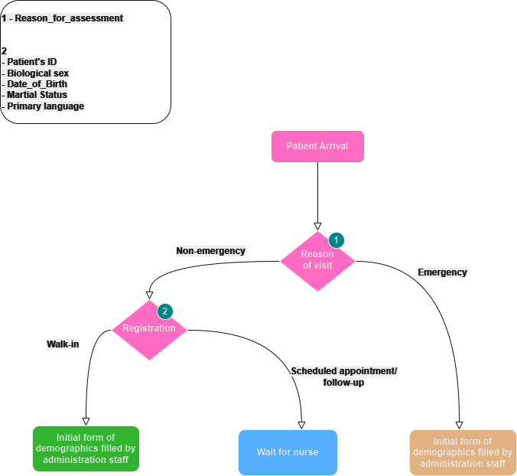

Illustration 1: An Overview of Patient Interactions at the Hospital

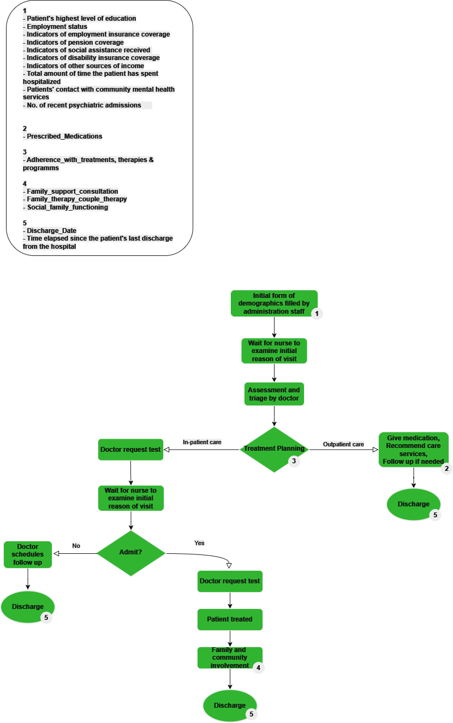

Illustration 2: Comprehensive Patient Data Collection for Enhanced Diagnosis and Treatment Planning: Non-Emergency Walk-In Scenario

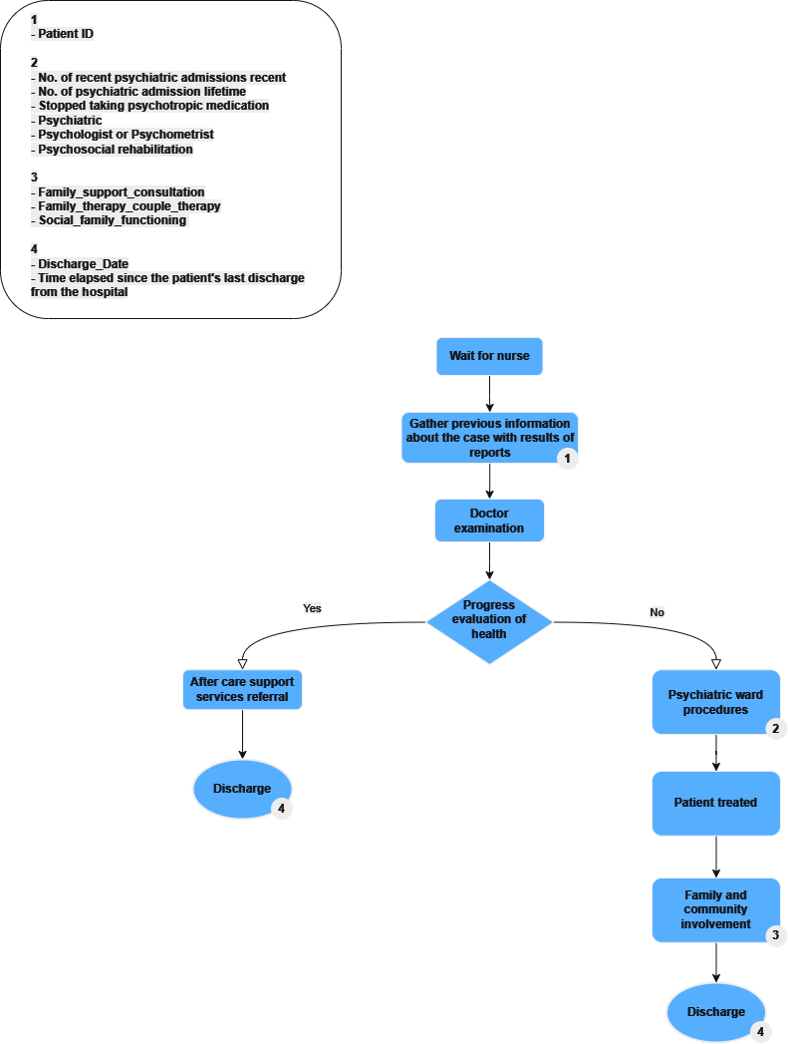

Illustration 3: Integrated Patient Assessment and Record Management in Hospital Appointments and Follow-ups

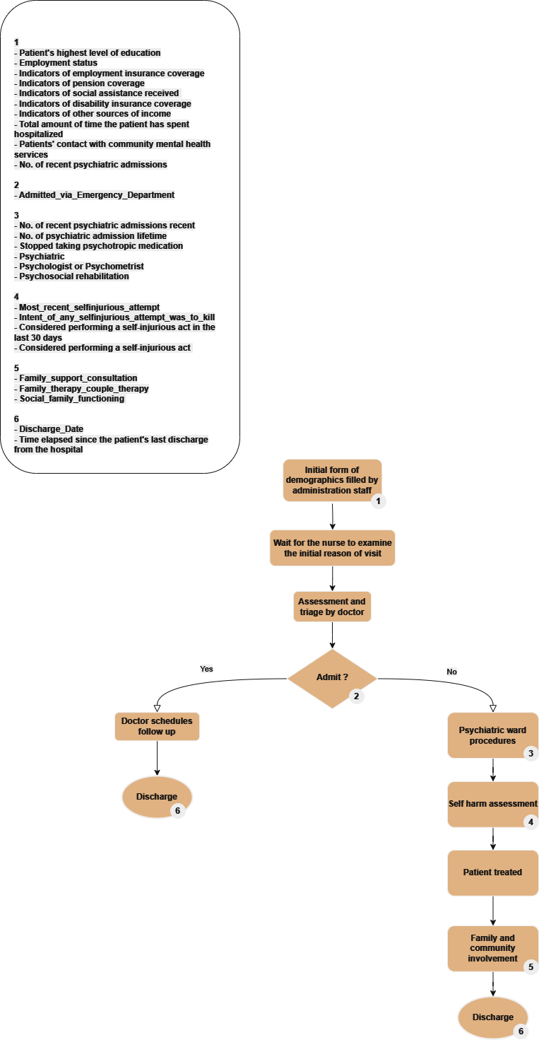

**Illustration 4: Streamlined Data Collection for Diagnosis and Treatment**

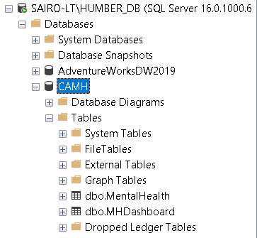

Illustration 5: Database Creation in SQL Server

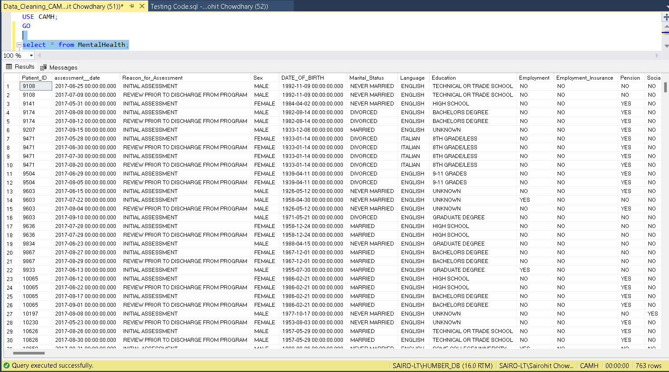

Illustration 6: Data from Excel Successfully transferred to the database and stored in MentalHealth Table

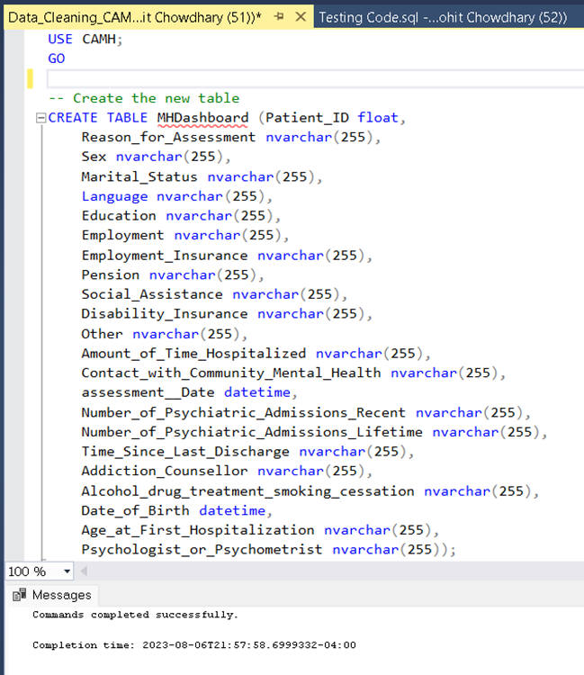

Illustration 7: Step 1 of MHDashboard table creation

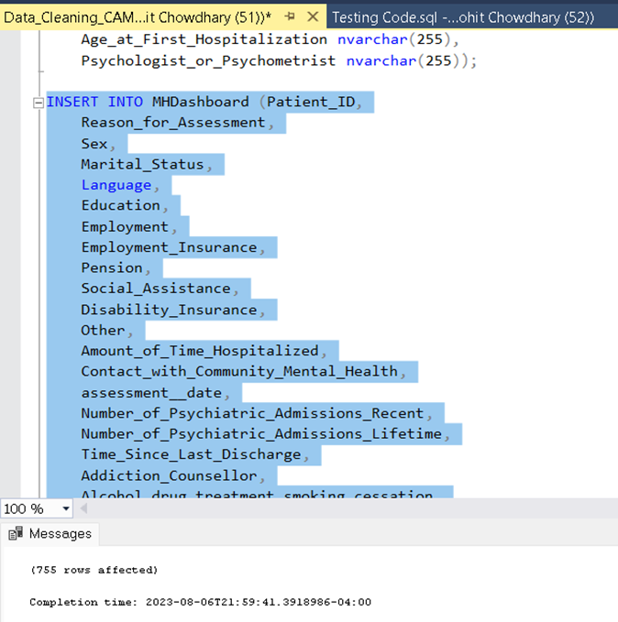

Illustration 8: Step 2 Inserting Data from MentalHealth table into MHDashboard table

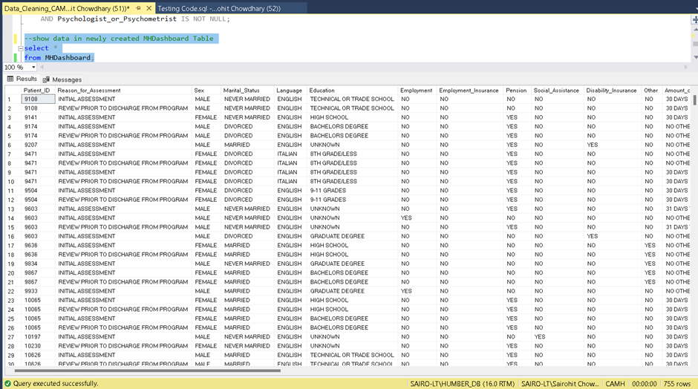

Illustration 9: Step 3 Displaying data inserted from MentalHealth table into MHDashboard table

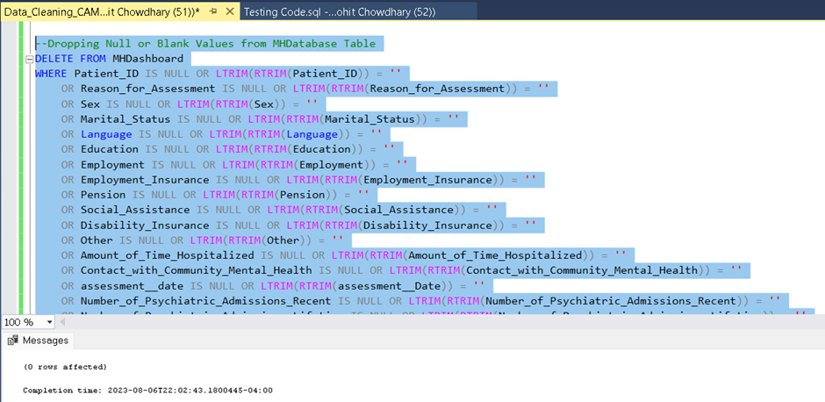

Illustration 10: Step 4 Dropping Null & Blank Values from MHDashboard table

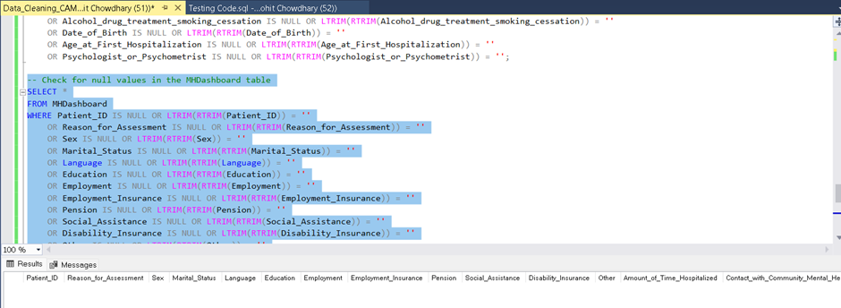

Illustration 11: Step 5 - Checking for Null Values in MHDashboard table

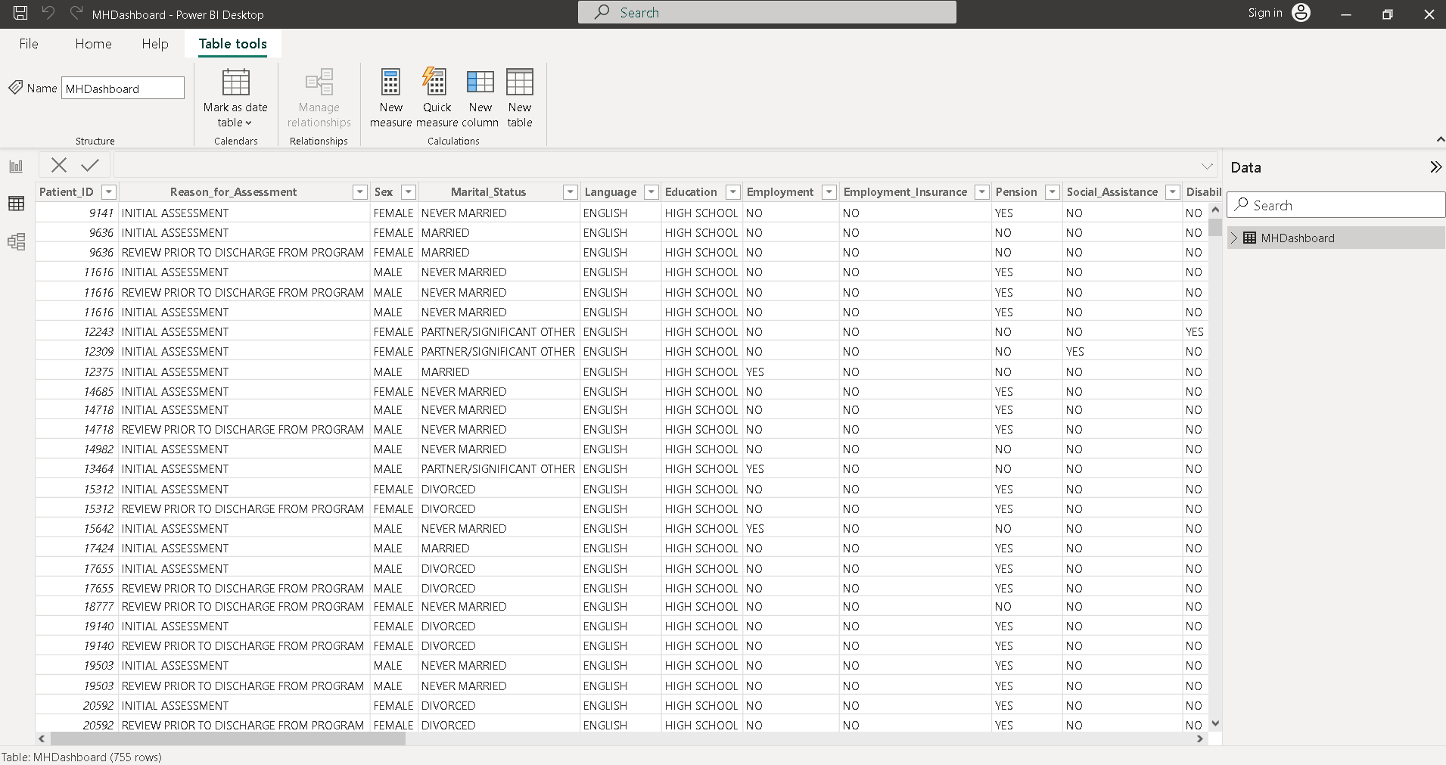

Illustration 12: Final Step - Integration of the refined dataset into the Power BI environment

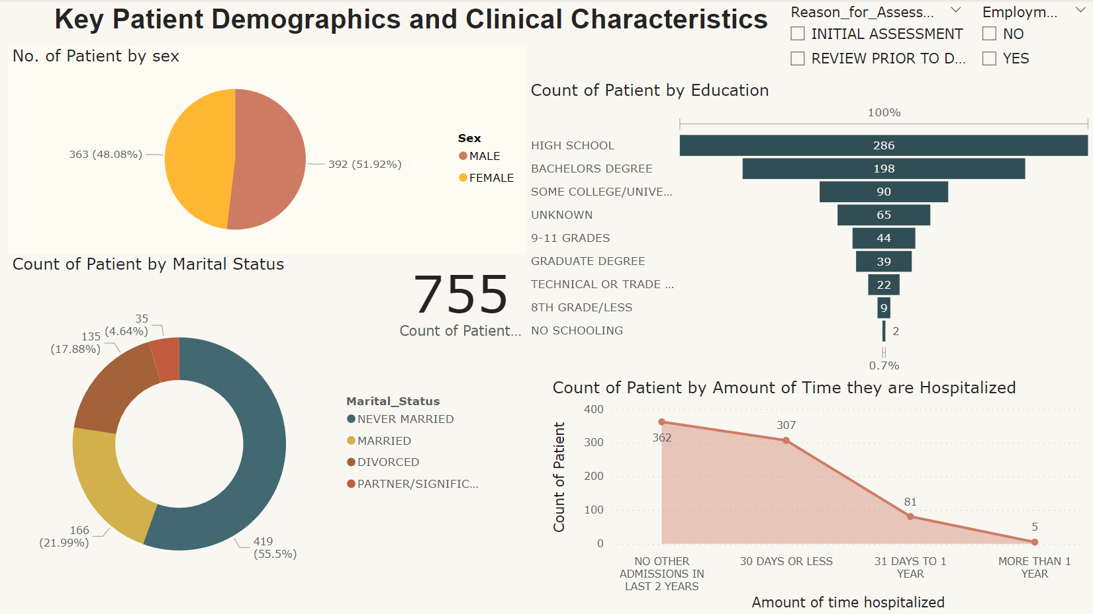

Dashboard 1: Key Patient Demographics and Clinical Characteristics.

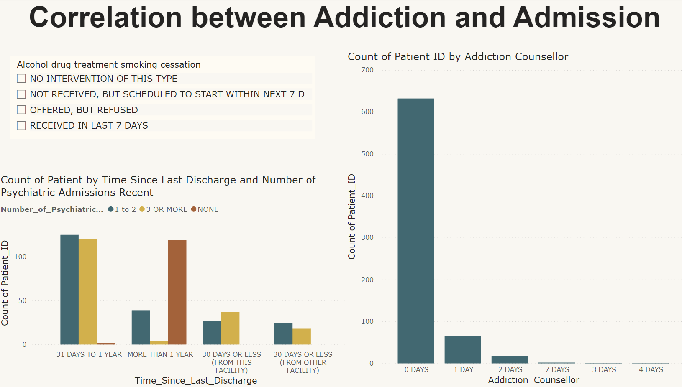

Dashboard 2: Correlation between Addiction and Admission.

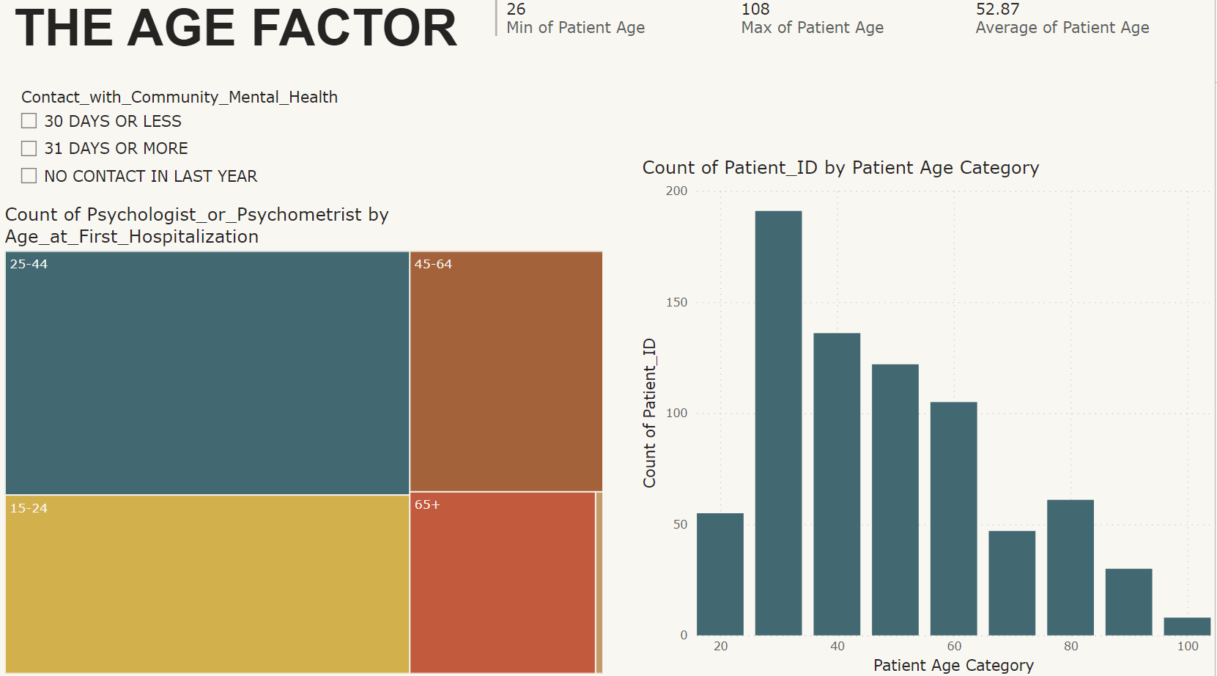

Dashboard 3: Correlation between Age and Mental Health Condition.

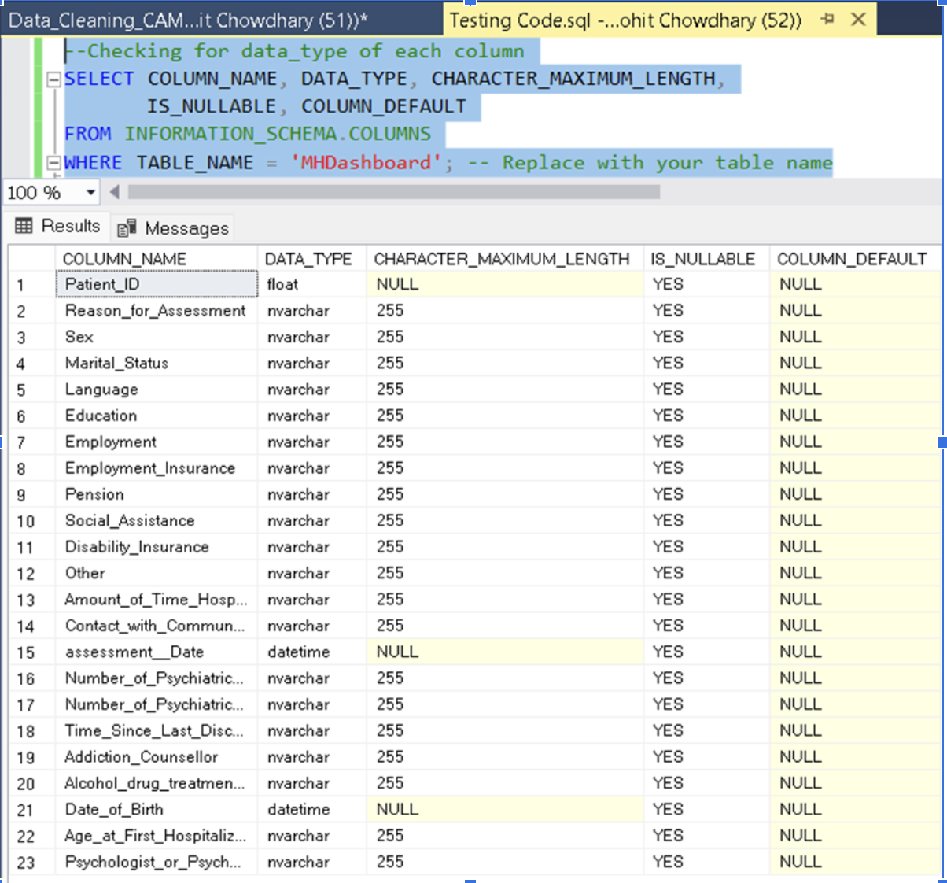

Illustration 13: Verifying the data types between the sample dataset and the actual database

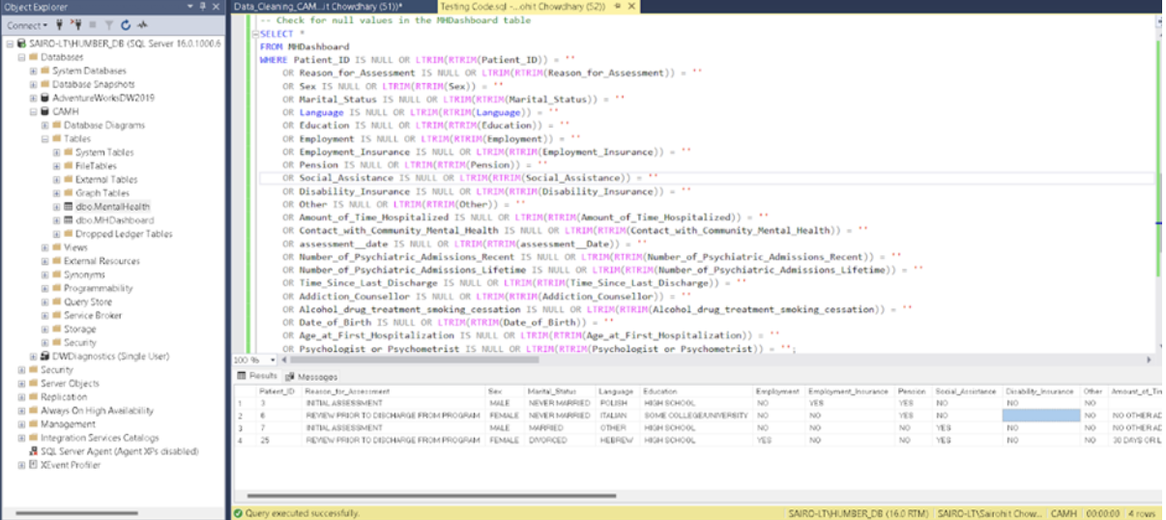

Illustration 14: Checking for missing information in the dataset after adding the sample data

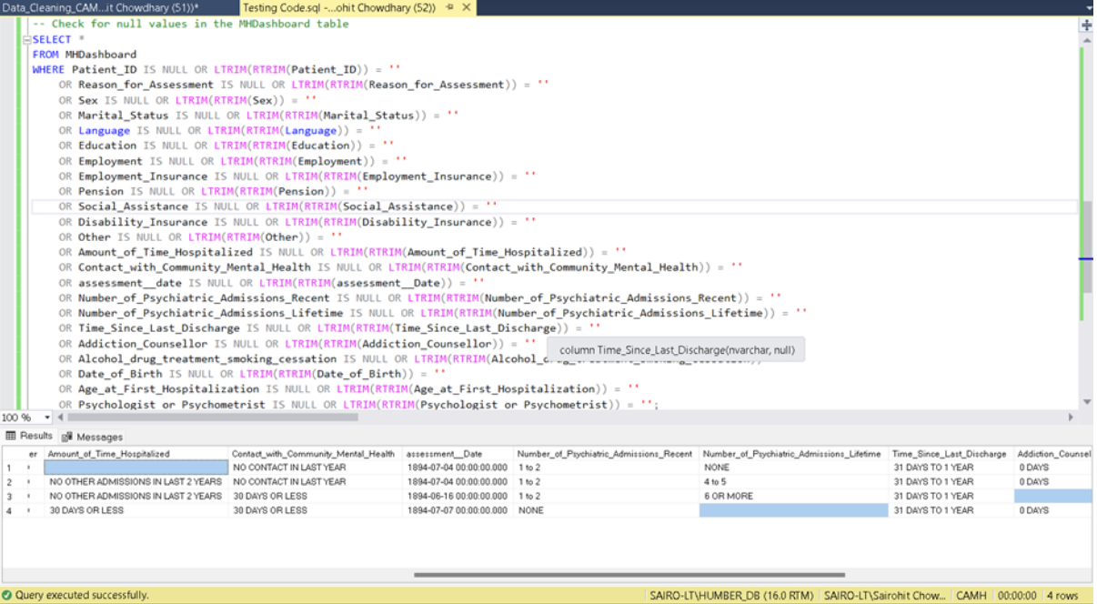

Illustration 15: Checking for missing information in the dataset after adding the sample data

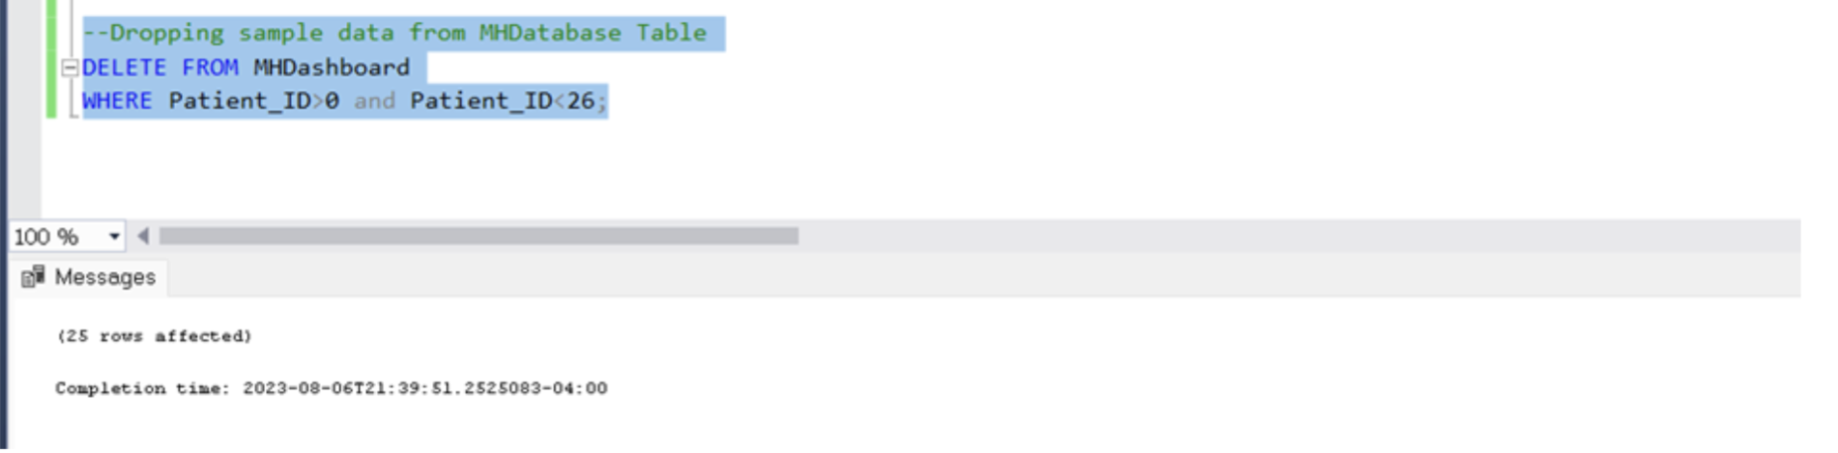

Illustration 16: Removal of the sample data

**12. References**

Centre for Addiction and Mental Health. (2022, November 14). CAMH embraces the future of digital health.<https://www.camh.ca/en/camh-news-and-stories/camh-embraces-the-future-of-digital-health>

Matthews, K. (2019, November 20). *How centralized data improves the Health Care Industry*. CGcompliance.<https://info.cgcompliance.com/blog/how-centralized-data-improves-the-health-care-industry>